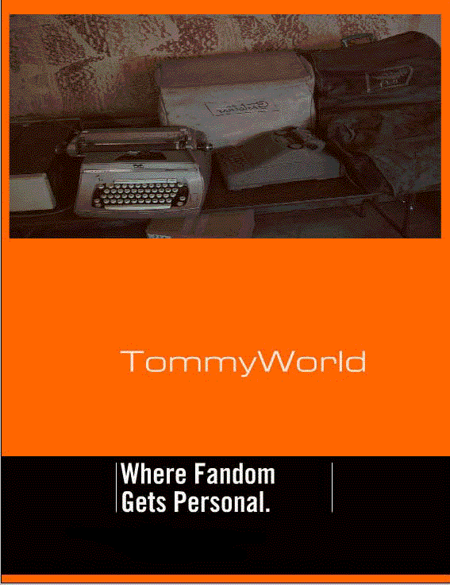
The Eighty Third issue of a sort-of-letter substitute, fanzine kinda thing. Maybe weekly, maybe not. Available from:

125 Haypark Ave, Belfast, BT7 3FG, Northern Ireland
TUtw@tommyworld.net
Uhttp://tommyworld.net

Available via the World Wide Web, or as an email attachment. I recommend the Portable Document Format (pdf) or, if you insist, a word or Rich Text Format (rtf) can also be emailed or posted. Get in touch and we’ll sort something out. Another burst of fannish energy from Tommy, proof read by Eugene Doherty. Dated, already, 31/03/2021.

Let There Be LoCs

TommyWorld 78 – mainly about the movie Leon

Taral Wayne I was worried that this was a virus ... recognizing a name is no guarantee. But it seems you were not a brain sucking computer bug after all... {Let’s not rush to judgement now…}

Leigh Edmonds Thanks for sending me your new issue of TommyWorld. I was a bit cautious about hitting the 'Download' link because, I don't know about you but I get stuff from all kinds of strange people over the interweb and goodness knows what kind of infection my computer could get as a result. But I'm glad that I gave in to temptation because I was disappointed when I found there were only two pages to this issue. {I do intend to put together a bigger issue of a fanzine – hopefully for Corflu in Bristol In Novemeber – but I like just riffing on a topic for a bit…}

When I find out the street address of a fan I usually look it up on Google Earth. Invariably I'm disappointed because it turns out that fans live in ordinary houses like mundane folks do. If I were in charge fans would get to live in much grander houses with at least a moat and a drawbridge. Dragons would be reserved for BNFs.

Thanks for the review of The Professional. I must have seen it but I can't recall it. You'd think I would because I always enjoy seeing Jean Reno on the screen with his well-practiced French style. I think I prefer him in his earlier French films - as I recall without looking he had parts in Subway and La Femme Nakita (both memorable films) and there are probably more that I haven't seen because I didn't catch them on SBS which shows a lot of non-English films. Like you, I like it when a number of the actors you like come together in one movie so I must look up The Professional to view again, and see if I've already seen it. Thanks for the tip. {All great movies – and well recommended to others out there. He’s such a versatile actor I even like him in Ronin and the first Hollywood remake of Godzilla – with the murderer Matthew Broderick – look that one up on your DuckDuckGo!}

Seamus McKenna A lovely blast from the past both in terms of the zine and the movie...Have to say I use four towels even after vigorous hand shaking. Maybe it's the useless NHS towels, bought on price not ability to absorb.... {and those of you with filthy minds, this references a particular scene in the movie I chatted about in TW78…} One part that sticks is Oldman taking the drugs just before the bust. Now, where did I put my copy of that movie.

Jim Caughran Thanks for the tworld. I have not seen Léon, but I'll see if I can find it. We got a Roku, which has more movies and tv and stuff than anyone could possibly watch. It may or may not have Léon. I enjoyed meeting you at Corflu. With the virus controlling us, I hope there will be another sometime.
Hope Leibowitz Hi Tommy! I hope you guys are doing as well as anyone can be doing in these nasty trying times! So, how long a gap has there been between TommyWorlds?! {Oh God, now there’s a question. I should ask my resident historian and proof reader Eugene Doherty – feel like I should put an @ sign in front of his name – as I’m sure he’ll know. May prompt him to write a letter as he reads this} I'm in an APA and people seem to be managing to do contributions, even though there isn't as much to write about as there used to be. We miss going to see jazz, and various other things.

Rob Jackson Thanks for TommyWorld 78, which arrived a day or two back and has been duly printed off ready for reply. Which is now...

Not being a film buff, my interest perked up when you started talking about washroom technology. Those of us of A Certain Age or older have to make mental adjustments to cope with all this new stuff, and despite my advancing years I have enough mental flexibility to find all these new developments good fun as well as environmentally beneficial. However I am conscious I am not a techno-native, but a techno-immigrant as far as all this new stuff is concerned.

My elder grandson Alex, now 8, is different. Even at 18 months or so he was utterly fascinated by machinery such as sliding doors and so on, and aged 3 we could see on taking him into the Gents in pubs or shopping malls that he was completely au fait with washroom taps and other facilities. {Kids are amazingly adaptive – my two constantly surprise me. I can recall when Abigail was a mere toddler I got a new phone. She was able to pinch and zoom in and out at will. Seemed to just know how to interact with the technology!}

David Redd Thanks for your email - glad to know you're still around and still active. I have to limit my reading time especially on screens, so do little with fandom these days, but if there's a dead-tree "TommyWorld Redux" still available, yes please I'd like one!. On Corflu, I have a supporting membership for 38 in Bristol, so still take an interest... {Hope this dead tree version finds you well – and I look forward to meeting you – and everyone else attending – at Corflu.org in November.}

Steve Jeffrey It is a brilliant film. Long time since I've seen it. Probably too long. Strange the things you see and pick up on when you watch a movie.

TommyWorld 79 – mainly about the Martha Well’s Murderbot series

Steve Jeffrey - again Whilst there are lots of spaceships, robots and fights in all the books there is also a bunch of stuff that will make you think. For example, the Murderbot is never assigned a gender, although I’ve seen discussion of this online in terms of gender and non-binary politics -with arguments for all and none. It also got me thinking about the nature of relationships and ‘love’ – do robots and spaceships love each other – how does that work? {I completely agree – I’ve re-read them recently and there is so much more going on. The end of the last one is really thought provoking on these vary issues}
Sue Thomason and I had a long and wide-ranging discussion in Vikki's Prophecy apa about personhood, embodiment, gender and identity after reading Anne Leckie's Ancillary series a couple of years back. I think most of the other members phased out after the third month and just left us to it. (Much the same thing happened with when we both read Anathem, earlier.) Sometimes, it seems, a book can unpack a whole lot more than is just contained between its covers. {I’m sure I’ve got a TommyWorld on Anne Leckie's work in me as well – love those books for many of the same reasons! I’m a big fan of Neal Stephenson but his later work – particularly Anathem and Seveneves – leave me really cold. I feel it is glib to say he needs an editor – but God he needs a better editor!}

TommyWorld 80 – mainly about how I choose ‘my’ soccer team

Keith Freeman Thanks for letter/pers/news zine (take your pick!) {Indeed – take your pick!} Fortuitous arriving in time to commiserate with your position - Arsenal (huurah) having beaten Chelsea... how are you going to console Maya? {She is fickle, it has to be said, and an hour on Minecraft soon distracts her.}

It brings back memories... At the end of the war (WW2, not the Boer War!) I was semi-evacuated to an aunt in Swansea. A cousin took me under his wing and we went and watched Swansea Town. I still have a soft spot for the Swans... However with the war in Europe over I returned home. My father tried to get me to support Charlton - with no luck (to get to their ground one had a long bus ride and a short tram ride - then you stood for more than an hour and a half followed by either a long walk to the bus terminus or a long queue for a tram). Having failed to get me to support his team he tried the local semi-professional - Dartford Town. This also entailed a bus ride to their ground, a seat (wow) in the stand followed by a walk down the hill (or a long queue for the infrequent bus) down into Dartford to get a trolley bus home.

I was still not convinced that the enjoyment outweighed the pain! Finally he found the solution - a team in the Kent Amateur League. Yes, a walk of probably a mile for home matches and away matches usually fairly easy to get to by car. Success. Of course after my parents moved away from Crayford I never got to watch them again (and I strongly suspect they no longer exist). So, why, now, do I say I support Arsenal... I really can't give a coherent reason - but then I suspect you, also, might not be able to give one for your support of them, can you? {Fantastic stuff – and probably says all you need to know about how people choose ‘their’ teams – apart from local towns etc. Great stuff! Here he is again:}

Reading that I see we were promised a lettercol in TW82. Now my memory may be decaying at a rate of knots... but I couldn't recall seeing any letter col in TW82. Second reading did confirm my suspicion that there was only one typo I'd previously noticed, but we won't go into that, and no visible letter-col. {You hear that Eugene?! Scandalous… From me almost expected, but to slip past you – unheard of!) Mystery solved - my non-loc on TW81 was the sole content of the letter col in TW82! So, now you have no excuse not to actually have a loc in TW83 (or at least a WAHF with my name in it!!) {And here you are.}
I confess I can't really be called a fnz fan - I enjoy reading them but rarely respond (count yourself as being in the unlucky minority) and even more rarely add content to them or create my own. No, I'm a SMALL Con fan - and I find Corflu to be an extremely enjoyable example of that breed. Indeed, in 1961 I swore (to myself) that I'd not get mixed up in ruinning another Con - now look, I've broken my promise after 59 years and am thoroughly mixed up (and, yes, enjoying) being involved with Corflu38 and hope to see you there on the just-a-minute-panel where your (and my) ignorance of sf (NOT Sci-Fi!!) will probably be revealed once again...
PS As is obligatory I have included one typo herein to obey the rule that any letter (email) drawing attention to a typo should have one.

Joseph Nicolas Thanks for the link to TommyWorld 81 -- although I have to say that I haven't the slightest interest in football, or indeed any other sports; a legacy, doubtless, of being forced out onto a school paying field (when schools still had playing fields -- before successive Conservative governments got them sold off) on Wednesday afternoons, irrespective of the weather, and forced to chase around after whatever happened to be the ball of choice (rugby, soccer, cricket...). Some kids loved it, perhaps because it gave them a chance to show off and be tough (especially, in secondary school, when they were showing off as much to the girls as to their immediate peers), but I hated it. I was a bookish type -- and still am. And I have carried forward my loathing of football unchanged ever since, for over half a century. That, you might say, is a proper hate....

WAHF: Ian Millsted, Colin Tate, Fred Lerner, Jo Zebedee, Bill Burns, Eugene Doherty, Mark McCann, Nic Farey, Ulrika O’Brien, Claire Brialey & Mark Plummer, Guy Lilian, Dave Langford, Malcolm Hutchinson

{Thanks one and all – I won’t be so lax next time round and will keep the conversation going. After all – despite Andy Hooper’s irreverent FAAN award interjection – that’s what we’re all doing here, eh?

